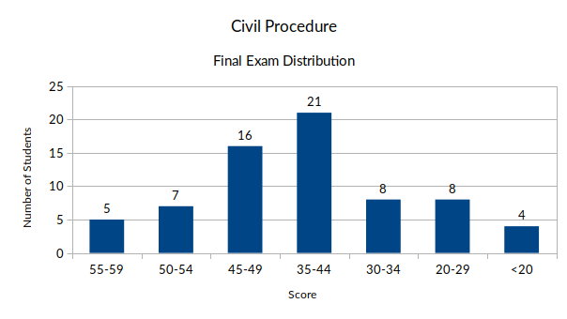High: 59

Low: 6

Mean: 40

Median: 42

Std. Dev.: 8.7

*Approximate Grade Ranges:*

55-59 A/A-

50-54 B+

45-49 B

35-44 B-

30-34 C+/C

20-29 C-

19 & below D+/D/D-